AIM:
To write a C program to simulate MFT(Multiprogramming with Fixed number of Tasks)

Program:
#include<stdio.h>
#include<conio.h>
main()
{
int ms,i,ps[20],n,size,p[20],s,intr=0;
clrscr();
printf("Enter size of memory:");
scanf("%d",&ms);
printf("Enter memory for OS:");
scanf("%d",&s);
ms-=s;
printf("Enter no.of partitions to be divided:");
scanf("%d",&n);
size=ms/n;
for(i=0;i<n;i++)
{
printf("\n Enter process and process size:");
scanf("%d%d",&p[i],&ps[i]);
if(ps[i]<=size)
{
intr=intr+size-ps[i];
printf("process%d is allocated\n",p[i]);
}
else
printf("\n process%d is blocked",p[i]);
}
printf("\n internal fragmentation is %d",intr);
getch();
}

Output:
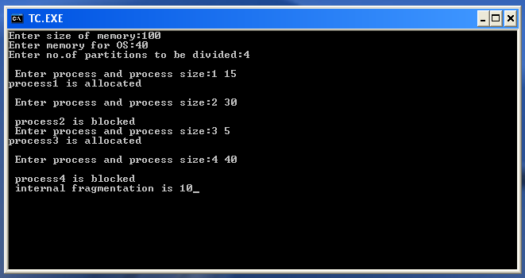

Aim:
To write a C program to simulate MVT (Multiprogramming with Variable number of Tasks)

#include<stdio.h>
#include<conio.h>
main()
{
int i,m,n,tot,s[20];
clrscr();
printf("Enter total memory size:");
scanf("%d",&tot);
printf("Enter no. of pages:");
scanf("%d",&n);
printf("Enter memory for OS:");
scanf("%d",&m);
for(i=0;i<n;i++)
{
printf("Enter size of page%d:",i+1);
scanf("%d",&s[i]);
}
tot=tot-m;
for(i=0;i<n;i++)
{
if(tot>=s[i])
{
printf("Allocate page %d\n",i+1);
tot=tot-s[i];
}
else
printf("process p%d is blocked\n",i+1);
}
printf("External Fragmentation is=%d",tot);
getch();
}

Output:
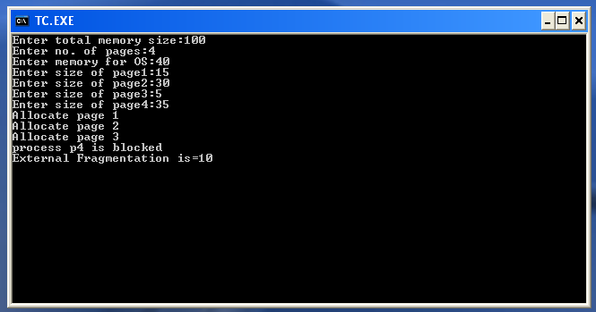

a) Worst Fit
#include<stdio.h>
#include<conio.h>
#define max 25
void main()
{
int frag[max],b[max],f[max],i,j,nb,nf,temp,highest=0;
static int bf[max],ff[max];
clrscr();
printf("\nEnter the number of blocks:");
scanf("%d",&nb);
printf("Enter the number of files:");
scanf("%d",&nf);
printf("\nEnter the size of the blocks:-\n");
for(i=1;i<=nb;i++)
{
printf("Block %d:",i);
scanf("%d",&b[i]);
}
printf("Enter the size of the files:-\n");
for(i=1;i<=nf;i++)
{
printf("File %d:",i);
scanf("%d",&f[i]);
}
for(i=1;i<=nf;i++)
{
for(j=1;j<=nb;j++)
{
if(bf[j]!=1) //if bf[j] is not allocated
{
temp=b[j]-f[i];
if(temp>=0)
if(highest<temp)
{
ff[i]=j;
highest=temp;
}
}
}
frag[i]=highest;
bf[ff[i]]=1;
highest=0;
}
printf("\nFile_no \tFile_size \tBlock_no \tBlock_size \tFragment");
for(i=1;i<=nf;i++)
printf("\n%d\t\t%d\t\t%d\t\t%d\t\t%d",i,f[i],ff[i],b[ff[i]],frag[i]);
getch();
}
Output:
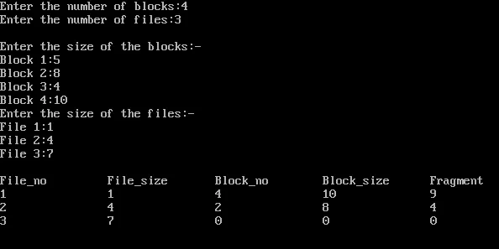

b) Best Fit
#include<stdio.h>
#include<conio.h>
#define max 25
void main()
{
int frag[max],b[max],f[max],i,j,nb,nf,temp,lowest=10000;
static int bf[max],ff[max];
clrscr();
printf("\nEnter the number of blocks:");
scanf("%d",&nb);
printf("Enter the number of files:");
scanf("%d",&nf);
printf("\nEnter the size of the blocks:-\n");
for(i=1;i<=nb;i++)
{
printf("Block %d:",i);
scanf("%d",&b[i]);
}
printf("Enter the size of the files:-\n");
for(i=1;i<=nf;i++)
{
printf("File %d:",i);
scanf("%d",&f[i]);
}
for(i=1;i<=nf;i++)
{
for(j=1;j<=nb;j++)
{
if(bf[j]!=1)
{
temp=b[j]-f[i];
if(temp>=0)
if(lowest>temp)
{
ff[i]=j;
lowest=temp;
}
}
}
frag[i]=lowest;
bf[ff[i]]=1;
lowest=10000;
}
printf("\nFile_no \tFile_size \tBlock_no \tBlock_size \tFragment");
for(i=1;i<=nf && ff[i]!=0;i++)
printf("\n%d\t\t%d\t\t%d\t\t%d\t\t%d",i,f[i],ff[i],b[ff[i]],frag[i]);
getch();
}
Output:
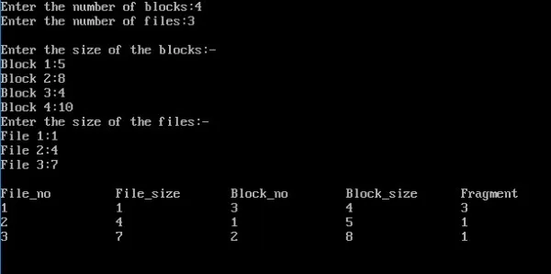

c) First Fit
#include<stdio.h>
#include<conio.h>
#define max 25
void main()
{
int frag[max],b[max],f[max],i,j,nb,nf,temp;
static int bf[max],ff[max];
clrscr();
printf("\nEnter the number of blocks:");
scanf("%d",&nb);
printf("Enter the number of files:");
scanf("%d",&nf);
printf("\nEnter the size of the blocks:-\n");
for(i=1;i<=nb;i++)
{
printf("Block %d:",i);
scanf("%d",&b[i]);
}
printf("Enter the size of the files:-\n");
for(i=1;i<=nf;i++)
{
printf("File %d:",i);
scanf("%d",&f[i]);
}
for(i=1;i<=nf;i++)
{
for(j=1;j<=nb;j++)
{
if(bf[j]!=1)
{
temp=b[j]-f[i];
if(temp>=0)
{
ff[i]=j;
break;
}
}
}
frag[i]=temp;
bf[ff[i]]=1;
}
printf("\nFile_no:\tFile_size :\tBlock_no:\tBlock_size:\tFragment");
for(i=1;i<=nf;i++)
printf("\n%d\t\t%d\t\t%d\t\t%d\t\t%d",i,f[i],ff[i],b[ff[i]],frag[i]);
getch();
}
Output:
